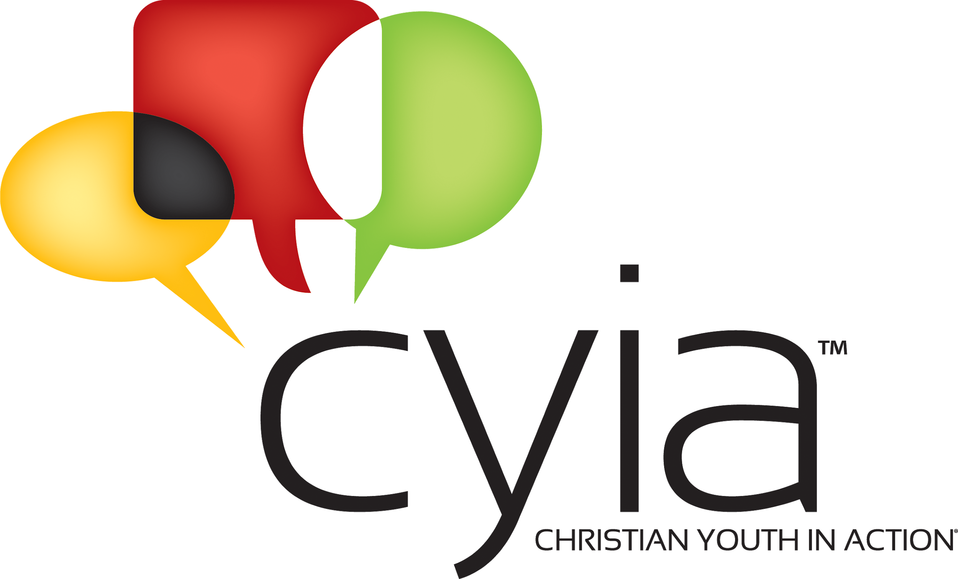
Child Evangelism Fellowship of MI
4301 W. Mt. Hope Hwy
Lansing, MI 48917
517-322-2193
Reference Form
This individual has applied to Child Evangelism Fellowship® as a summer worker and has chosen you as a reference. A personal recommendation gives insights that would be very helpful in determining the person’s ability to perform his/her responsibilities. Please print and be candid and objective.

Name of Applicant Click or tap here to enter text.
Name of Reference Click or tap here to enter text.
1. How long have you known the applicant? _____________________________
2. In what relationship do you know the applicant?
☐Pastor/Spiritual Leader ☐Non-relative adult friend
3. How well do you know the applicant? (circle one) ☐Very Well ☐Well ☐Casually
4. Is there any reason known to you why the applicant should not work with children? ☐ Yes ☐No
If yes, please comment Click or tap here to enter text.
5. What is the applicant’s attitude toward authority? ☐Excellent ☐Good ☐ Average ☐Poor
6. What is the applicant’s general outlook on life? ☐Positive ☐Pos/Neg ☐ Neg/Pos ☐Negative
7. Does the applicant work well with others? ☐Yes ☐No
If no, please comment Click or tap here to enter text.
8. Are you aware of any unbiblical sexual tendency in the applicant? ☐Yes ☐No
If yes, please comment Click or tap here to enter text.
9. What is the applicant’s work ethic? ☐Dependable ☐Undependable
10. How would you rate the applicant’s standards for Christian living? ☐Good ☐Average ☐Poor
11. How may we contact you if we have questions?
Phone: Click or tap here to enter text.Email: Click or tap here to enter text.
Position or occupation: Click or tap here to enter text.
Address Click or tap here to enter text.
City Click or tap here to enter text. St Click or tap here to enter text. Zip Click or tap here to enter text.

Signature: Click or tap here to enter text. DateClick or tap here to enter text. (Typing your name on the signature line holds same authorization as your written signature)

Mail this reference to: CYIA Registrar
4215 W Mount Hope Hwy
Lansing MI 48917
517.322.0001

Please return this form by May 15, 2022

